**Experimental Results**

How I tested my results

1. Start with a fully implemented player and one only partially implemented e.g defensivePlayer with all functions added and offensivePlayer with only one function added
2. Play a 1000 round match between these players on a set seed
3. Take note of the results, then add another function to the partially implemented player
4. Repeat from step 2 until the partially implemented player is fully implemented

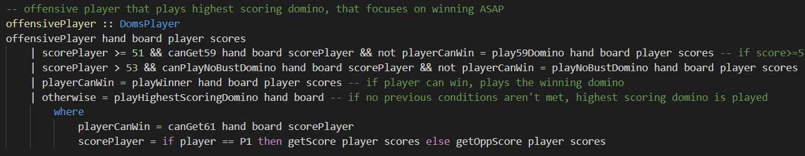

Experiment 1 – offensivePlayer fully implemented, defensivePlayer partially implemented, offensivePlayer:

* Plays (5,4) if it has first drop
* Plays a domino to reach 59 if possible
* If it cannot reach 59, it plays highest scoring domino such that it will not bust
* If offensivePlayer can play a domino to score 61, it will do so
* If it cannot do any of the above, offensivePlayer plays the highest scoring domino

**Experiment 1.1 (seed = 42)**

|  |  |  |  |
| --- | --- | --- | --- |
| Score (left is offensivePlayer, right is defensivePlayer) | defensivePlayer functions implemented | Changes | Comments |
| (552, 448) | playHighestScoringDomino | N/A | offensivePlayer much better than the basic defensivePlayer |
| (493, 507 | playHighestScoringDomino  playWeakDomino | Added playWeakDomino | Adding this function proved to be advantageous for the given seed |
| (419, 581) | playHighestScoringDomino  playWeakDomino  playWinner | Added playWinner function | Adding the playWinner function was hugely advantageous on this seed |
| (415, 585) | playHighestScoringDomino  playWeakDomino  playWinner  play59Domino | Added play59Domino function | Getting the player to play a domino to reach 59 didn’t help on this particular seed |

**Experiment 1.2 (seed = 23)**

|  |  |  |  |
| --- | --- | --- | --- |
| Score (left is offensivePlayer, right is defensivePlayer) | defensivePlayer functions implemented | Changes | Comments |
| (563, 437) | playHighestScoringDomino | N/A | offensivePlayer much better than the basic defensivePlayer |
| N/A | playHighestScoringDomino  playWeakDomino | Added playWeakDomino | Adding this function didn’t output a result – took too long |
| (491, 509) | playHighestScoringDomino  playWinner | Added playWinner function, removed playWeakDomino | Adding the playWinner function was again advantageous on this seed and removing the playWeakDomino function meant the game was played |
| (486, 514) | playHighestScoringDomino  playWinner  play59Domino | Added play59Domino function | Getting the player to play a domino to reach 59 didn’t help on this particular seed again |

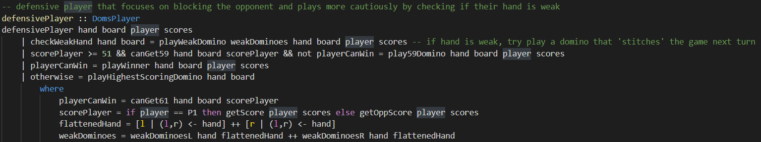

Experiment 2 – defensivePlayer fully implemented, offensivePlayer partially implemented, defensivePlayer:

* Plays (5,4) if it has first drop
* Plays a domino to reach 59 if possible
* If it has a weak hand, checks to find the weakest domino, and plays it
* If offensivePlayer can play a domino to score 61, it will do so
* If it cannot do any of the above, offensivePlayer plays the highest scoring domino

**Experiment 2.1 (seed = 12)**

|  |  |  |  |
| --- | --- | --- | --- |
| Score (left is offensivePlayer, right is defensivePlayer) | defensivePlayer functions implemented | Changes | Comments |
| (409, 591) | playHighestScoringDomino | N/A | defensivePlayer much better than the basic offensivePlayer |
| (477, 523) | playHighestScoringDomino  playWinner | Added playWinner | Adding this function proved to be advantageous for the given seed |
| (482, 518) | playHighestScoringDomino  playWinner  play59Domino | Added play59Domino | Adding the play59Domino was disadvantageous in this seed |
| (437, 563) | playHighestScoringDomino  playWinner  play59Domino  playNoBustDomino | Added playNoBustDomino | Adding this function was again was disadvantageous to the player |

**Experiment 2.2 (seed = 23)**

|  |  |  |  |
| --- | --- | --- | --- |
| Score (left is offensivePlayer, right is defensivePlayer) | defensivePlayer functions implemented | Changes | Comments |
| (440, 560) | playHighestScoringDomino | N/A | offensivePlayer much better than the basic defensivePlayer |
| (503, 497) | playHighestScoringDomino  playWinner | Added playWinner | Adding this function helped a huge amount for this seed |
| (510, 490) | playHighestScoringDomino  playWinner  play59Domino | Added play59Domino | Adding the play59Domino was advantageous in this seed, usually it isn’t |
| (486, 514) | playHighestScoringDomino  playWinner  play59Domino  playNoBustDomino | Added playNoBustDomino | Adding this function didn’t help on this seed |

**Conclusion**

* playHighestScoringDomino – clearly an advantageous function, from playing against randomPlayer, it was clear that this consistently beat playing a random domino
* playWinner – consistently advantageous as it allows the player to go for the win when possible
* play59Domino – inconsistent, was mostly disadvantageous but one on occasion was advantageous, maybe not worth implementing
* playNoBustDomino – usually advantageous, but on one occasion, was disadvantageous, worth implementing